

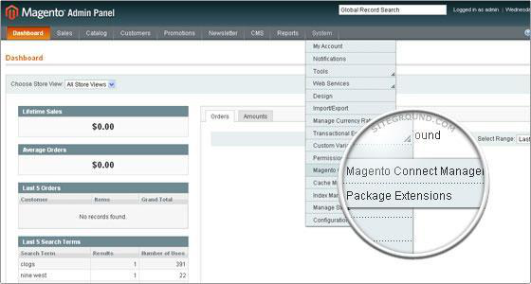
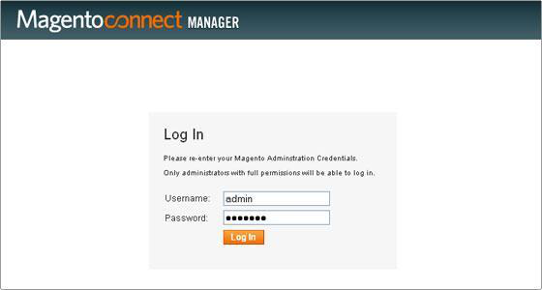
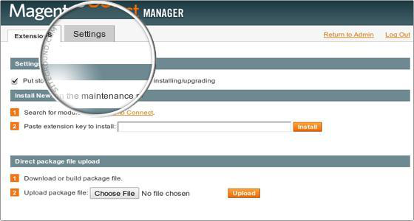
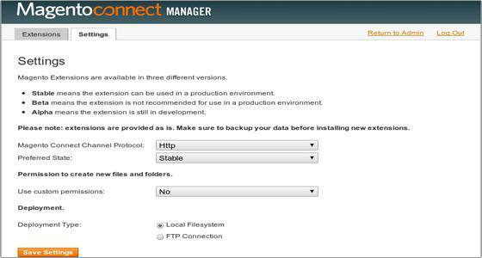
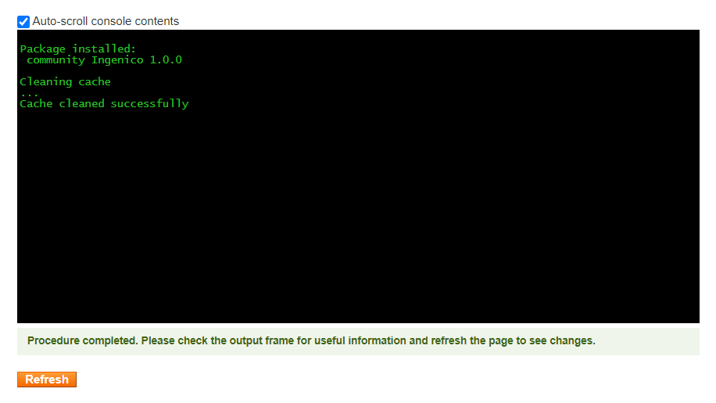
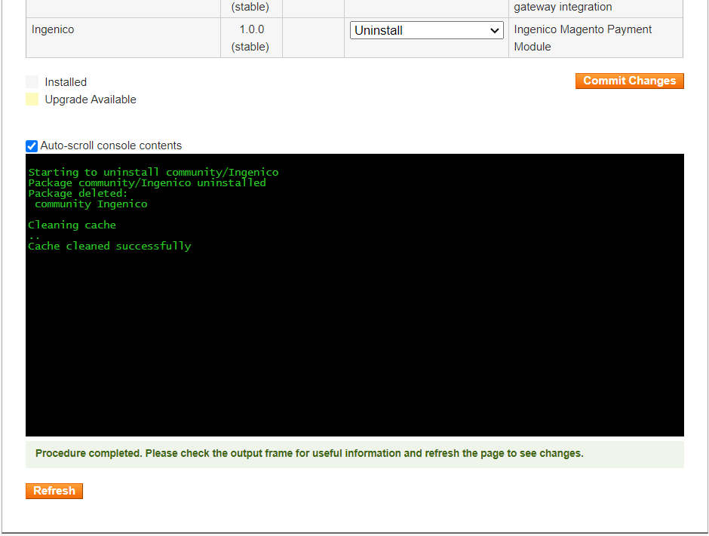
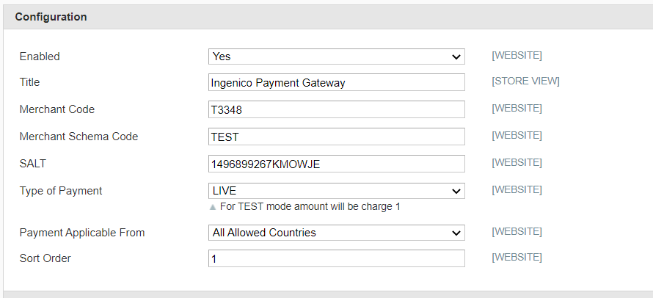
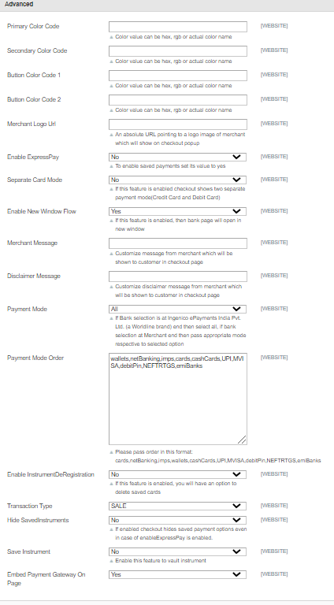
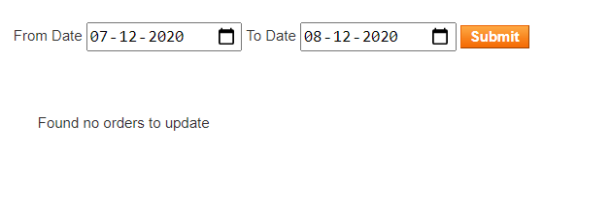
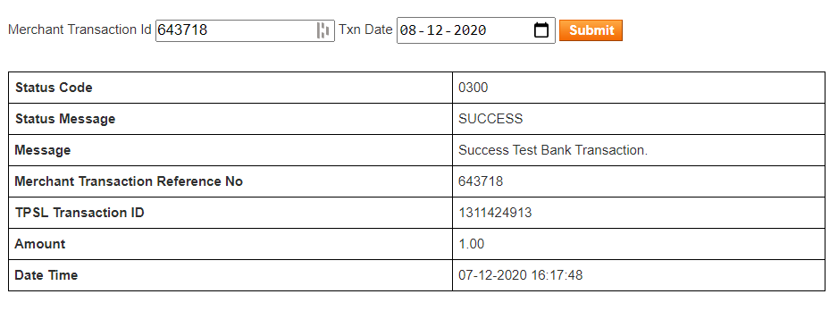
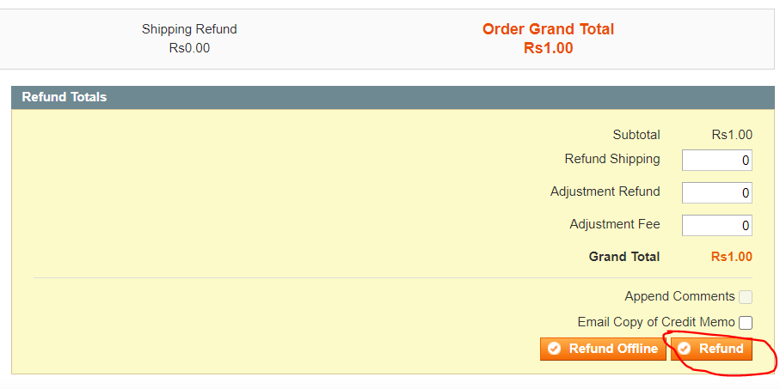

INSTALLATION MANUAL

Table of Contents

Applicable Version………………..….……………………………….……………………….………1

Installation....………………………….……….………………………………………………………….1

Configuring worldling……………………………………………………………………………………6

Applicable versions

Applications | Versions
PHP | 5.3.x to 5.6.x
Magento | 1.7.x to 1.9.x

Installation

Please follow the given steps to install and run the worldling Payment Gateway module

- First, you need to log in to the Magento administrator area.
  - Visit URL www.<mysite.com>/admin.
  - Enter Username and password.
- Then go to System -> Magento Connect -> Magento Connect Manager.
- A new page will open for the Magento Connect Manager and you will be asked to provide your administrative credentials again.

- Once logged in you will see 2 sections: Extensions and Settings. It is recommended to verify the options chosen in the Settings section first.

- In the Settings section you can configure options if you need to do. It is safe to leave those options to their default values.
- Go to Extensions. In the “Direct package file upload” tab click on “Browse” button to upload the package file. Select worldling.tar file provided by worldling payment gateway module and click open. Now click “upload” to start uploading files.
- Wait until you get a message as “Package Installed”. The Console Box displays the results of your install. If there are any issues, it will be displayed in this box. After the extension is properly installed a screen for a successful installation will appear:

- Click refresh. Once the extension is installed it is important to go back to Magento admin (Click on Return to admin).
- worldling is now installed on your site.

Upgrade

- To upgrade the module we have to uninstall the previously installed module. So we have to navigate to the Magento connect manager as per the previous steps and then find the “worldling” module from the list. Select Uninstall the from the dropdown and Click on “Commit Changes”

- Once the uninstall is successful, you can install the extension again as shown in the installation steps above

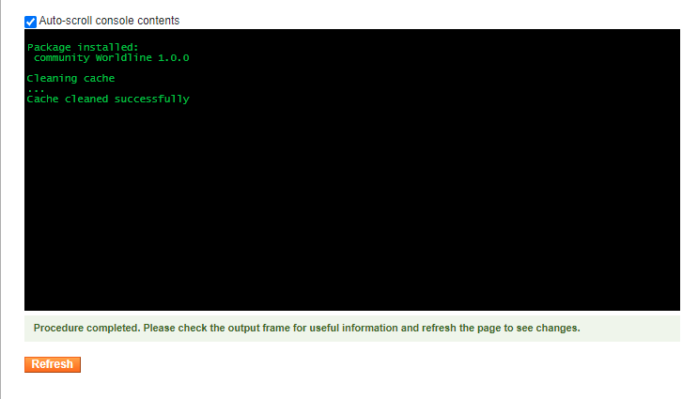

Configuring worldling

- Go-to admin panel.
- Go-to menu System->Configuration.
- Select “Payment methods” under the “Sales” tab on the left panel.
- Now you should be able to see the worldling Payment Gateway. Click on configure.
- Configure it as below:
Column Name | Description
Enabled | “Yes” to enable and use, else “No” to disable worldling
Title | Title Text to display during checkout process
Salt | Enter Salt.
Merchant Code | Enter merchant code.

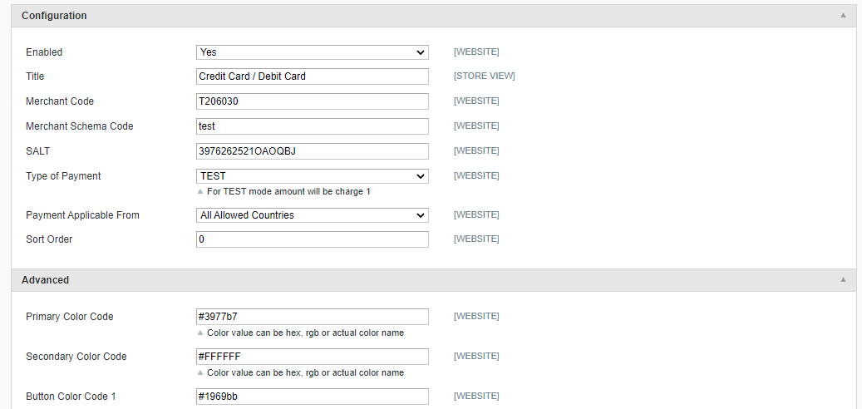

- Now click on “Save Config” on top- right corner.
- worldling Payment Gateway is now configured & ready to use.
Advanced Configuration
There are also some advanced configuration options you may consider as shown below:

Features List

Dual verification of response:
We are validating responses with a hash value and call again Payment Gateway for dual verification from the payment gateway before updating to the order status.

Reconciliation
Merchants can update the pending status of the order automatically if the payments are successful. This page can be found under worldling > Reconciliation

Logs request and response
Daily new file creates for the logs request and response from the server for future reference.

S2S Verification
If we do not receive any response from the payment gateway then after 30 mins, we will get a response from the server and based on the response it will update order status.
To configure S2S URL, contact prod team.

S2S url format : http://DOMAIN_NAME/index.php/worldling/payment/s2sverification or https://DOMAIN_NAME/index.php/worldling/payment/s2sverification
S2S url example : http://example.com/index.php/worldling/payment/s2sverification

MCG
It supports the multi currency like USD, GBP, SGD and a lot more.

Payment Verification
Merchants can verify the status of their payment by using the Payment Verification page. The payment verification page can be found under worldling > Payment Verification

Refund
Merchants should be able to process the refund online for the order whose payment has been done via worldling.

To refund a order, create a new Credit Memo and click on the Refund button as shown below

Embed Payment Gateway
After enabling this setting, payment gateway displays like embedded on the page instead of pop-up so user experience would be good.

Documentation link
https://www.tecprocesssolution.com/proto/p2m/client/salt-based-documentation.htm#online

